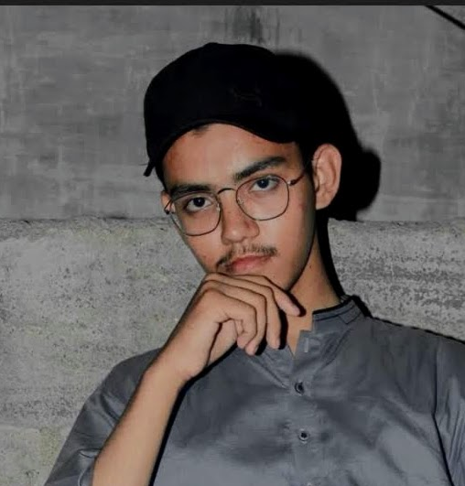
03060821530
uuh112442@gmail.com
https://usaid-portfolio.web.app/

USAID SIDDIQ

Summary
Senior Web Developer specializing in front end development. Experienced with all stages of the development cycle for dynamic web projects. Well-versed in numerous programming languages including HTML5, PHP OOP, JavaScript, CSS, MySQL. Strong background in project management and customer relations.

Skill Highlights
- HTML5  - CSS3  - Javascript  - Angular  - React(less) | - PHP  - Mysql

Experience
Web Developer - 09/2021 to 05/2022
Fresh

Education
Matric: ummul qura – 2021
Karachi,Pakistan

Certifications
Programming Languages: JavaScript, HTML5, CSS.

